产品主要参数/功能
摄像机 | 描述
主芯片 | CV1821
传感器 | SC3335/GC4653/SC401AI/OV4689/SC4336
分辨率 | 2304x1296P、2560x1440P
对角视角 | 106°
镜头焦距 | 4mm/6mm
夜视功能 | 红外/全彩夜视
音视频 | 描述
视频编码协议 | H.264/H.265
视频码率 | 80Kbps~1Mbps（自适应）
音频压缩方式 | G.711A/AAC
功能 | 描述
3D数字降噪 | 支持
宽动态 | 支持
背光补偿 | 支持
白平衡 | 支持
IR-CUT | 支持
POE供电 | 支持
智能 | 描述
人形侦测 | 支持
移动侦测 | 支持
声音侦测 | 支持
云广播 | 支持
声光报警 | 支持
网络 | 描述
网络协议 | L2TP, IPv4, IGMP, ICMP, ARP, TCP, UDP, DHCP,RTP,RTSP, RTCP,UPnP, DNS,PPPoE,DDNS,NTP, FTP,HTTP, HTTPS,SIP, 802.1x
接口 | 描述
音频输入输出 | 音频接线，1路输入，2路输出
电源 | 12V⎓1A/PoE 48V⎓0.3A
按键 | RESET按键
网口 | RJ45 10M/100M 自适应以太网电口
存储 | 描述
本地存储 | Micro SD，最大128GB
通用 | 描述
工作环境 | -20℃ to +60℃

晶视CV1821+SC3335/GC4653/SC401AI/OV4689/SC4336接线图
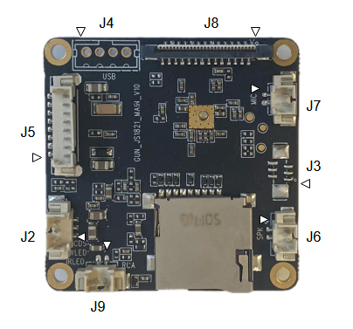
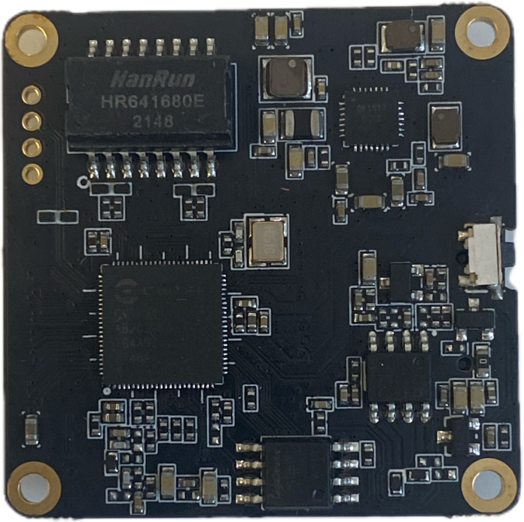

接口 | 描述
J4 | 1:12V_IN 2:USB_DP 3:USB_DM 4:GND
J8 | 1:VCC3.3 2:VCC1.8 3:VCC1.2 4:SEN_PWDN 5:CAM_RST 6:CAM_I2C_SCL 7:CAM_I2C_SDA 8:GND 9:CAM_MCLK 10:GND 11:CAM_RX_0N 12:CAM_RX_0P  13:GND 14:CAM_RX_1N 15:CAM_RX_1P 16:GND 17:CAM_RX_2N 18:CAM_RX_2P 19:GND 20:CAM_RX_3N 21:CAM_RX_3P 22:GND 23:CAM_RX_4N 24:CAM_RX_4P 25:GND 26:IR_CUT_P 27:IR_CUT_N 28:IRC_PWR
J7 | 1:MIC_IN 2:GND
J3 | 1:GPIO1 2:GPIO2 3:GPIO3 4:GPIO4 5:GPIO5 6:GND
J6 | 1:SPK- 2:SPK+
J9 | 1:RCA_OUT 2:GND
J2 | 1:IRLED 2:WLED 3:CDS
J5 | 1:12V_IN 2:GND 3:ETH_RX- 4:ETH_RX+ 5:ETH_TX-  6:ETH_TX+ 7:PHY_LED 8:KEY

